# IoT-Based Agricultural Project

**Monitoring Diseases and Pests in Crops**

**Submitted by:**  
Tal Bahir – 315307975  
Or Ben Hamo – 206487266  
Stanislav Etkin -

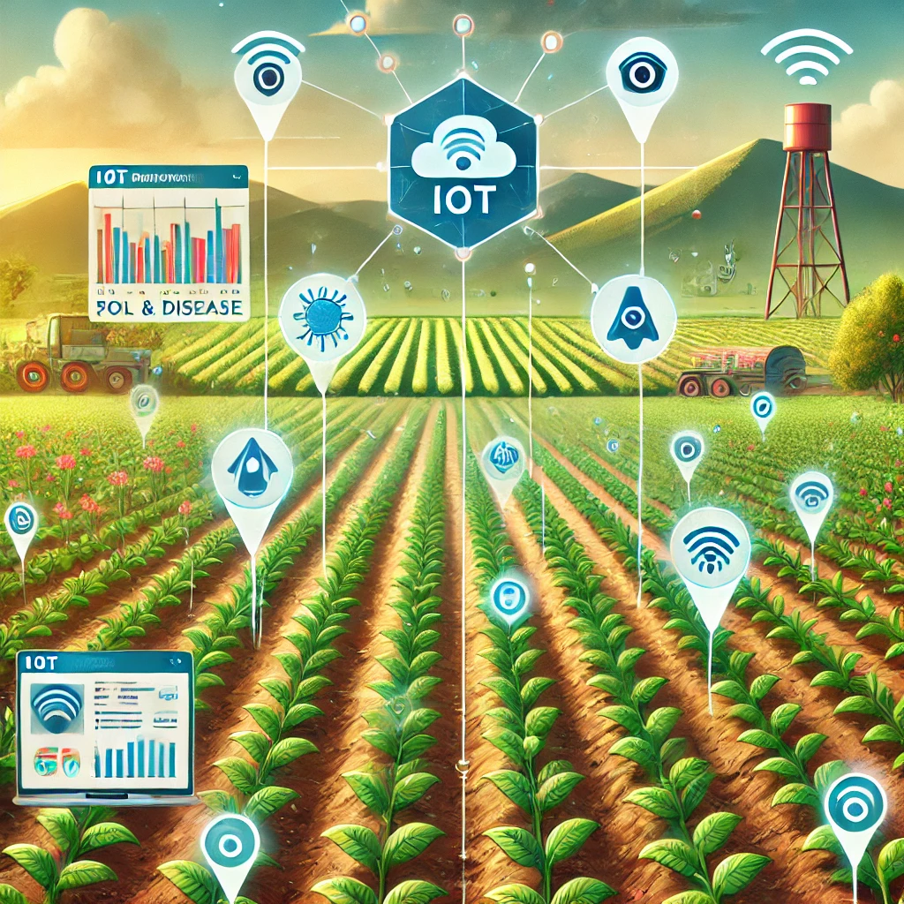

### Abstract

The goal of the project is to develop an IoT-based system for monitoring infections and diseases in avocado trees. The system uses a camera to detect symptoms on leaves and sensors to monitor environmental conditions such as air and soil humidity. The prototype is designed to assist farmers in early detection of diseases, thereby preventing widespread damage to plantations. The system is designed to provide accurate data and real-time alerts on problematic conditions.

**Key Achievements:**

* Successful integration of a camera with the M5Stick C controller
* Combining air and soil humidity sensors for environmental monitoring
* Initial disease diagnosis using an image-based algorithm

**Key Challenges:**

* Analyzing images with varying quality due to changing lighting conditions
* Calibrating sensors under field conditions

### Introduction

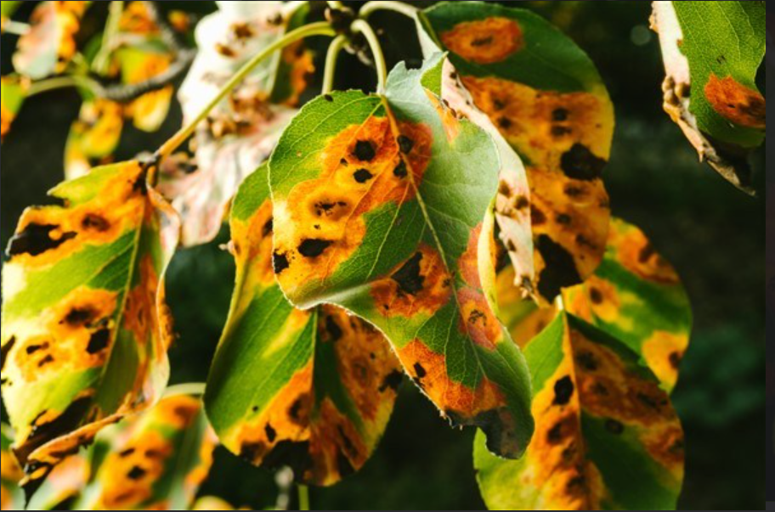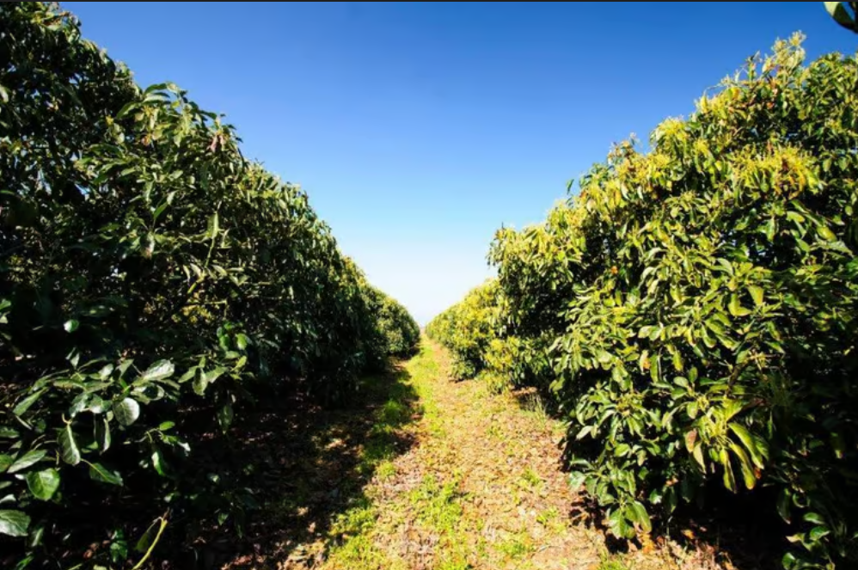Avocado trees are susceptible to various diseases that can cause significant economic losses for farmers. One of the major challenges is early detection of symptoms on leaves and environmental conditions that promote disease development. Currently, most inspection processes require human intervention and rely on the expertise of farmers or professionals.

**The project aims to:**

* Develop an automated IoT system to identify disease symptoms on avocado leaves
* Monitor and analyze environmental conditions to detect risk factors
* Provide smart alerts to farmers for prompt and precise intervention

The project contributes to improved efficiency and sustainability in agriculture, addressing the need for effective early detection of avocado tree diseases.

### User Requirements and System Needs

**Functional Requirements:**

* The system will identify visual signs of leaf diseases using a camera.
* The system will monitor soil and air humidity and compare the data to ideal values.
* The system will send real-time alerts to farmers based on collected data.

**Non-Functional Requirements:**

* High accuracy in leaf disease detection.
* High reliability of sensors under variable field conditions.
* Low power consumption suitable for the M5Stick C controller.

**Engineering Constraints:**

* Limited budget requiring the use of affordable and available components.
* Resistance to environmental conditions like high humidity and dust.
* Limited power consumption for extended field operation.

**Use Scenarios:**

* Installing the system in avocado plantations in Carmiel.
* Daily monitoring of tree conditions via remote data transmission.
* Regular use of the camera and sensors for continuous data collection.

### Research and Preliminary Design

**Review of Existing Solutions:**  
  
Preliminary research revealed that existing IoT systems for agricultural monitoring primarily focus on environmental conditions and lack visual disease detection capabilities. Our solution bridges this gap by combining environmental sensors and a camera for visual identification of diseases.

**Research Findings:**

* **M5Stick C Controller:** Compact, easy-to-use controller with built-in Wi-Fi connectivity.
* **Camera:** Captures leaf images and analyzes them to detect disease symptoms.
* 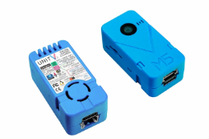**Soil and Air Humidity Sensors:** Enable continuous monitoring of critical environmental conditions.

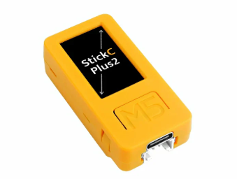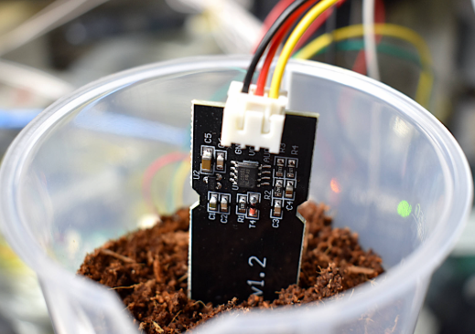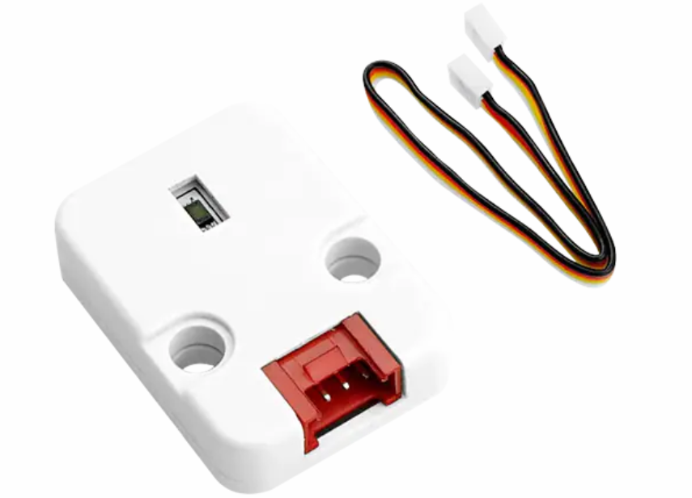

**Initial System Concept:**  
  
The system will integrate a camera, humidity sensors, and an M5Stick C controller connected to a Wi-Fi network. Data will be collected automatically, processed, and sent to the farmer with data-driven alerts.

**Key Design Decisions:**

* Use of a camera for visual disease symptom detection
* Integration of sensors for soil and air humidity monitoring

Wi-Fi connectivity for remote data transmissio

### System Architecture and Design

**System Architecture:**  
  
The system consists of three main components: hardware, software, and communication. The architecture diagram illustrates the connection between sensors, the controller, and the camera with a Wi-Fi interface for data transmission.

**Hardware Design:**

### oil Moisture Sensor

The soil moisture sensor measures the water content in the soil, providing critical data to optimize irrigation and maintain plant health. This ensures that plants receive adequate water while minimizing overwatering and resource waste.

### Air Humidity Sensor

The air humidity sensor monitors atmospheric moisture levels, which significantly impact plant transpiration rates and overall environmental conditions. This data is essential for understanding how external factors influence plant growth and disease development.

### M5Stick C Plus 2 Controller

The M5Stick C Plus 2 controller acts as the central hub of the system. It integrates data from the sensors and the camera, processes it in real time, and facilitates visualization and communication. Its compact design and built-in Wi-Fi capabilities make it ideal for IoT applications in agriculture.

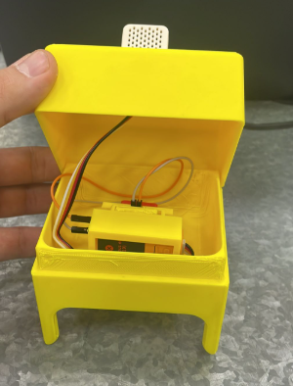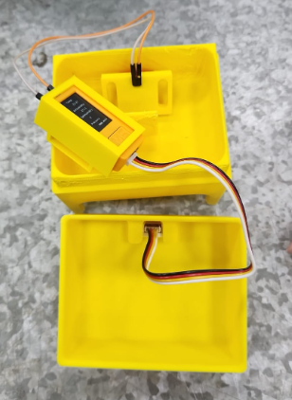

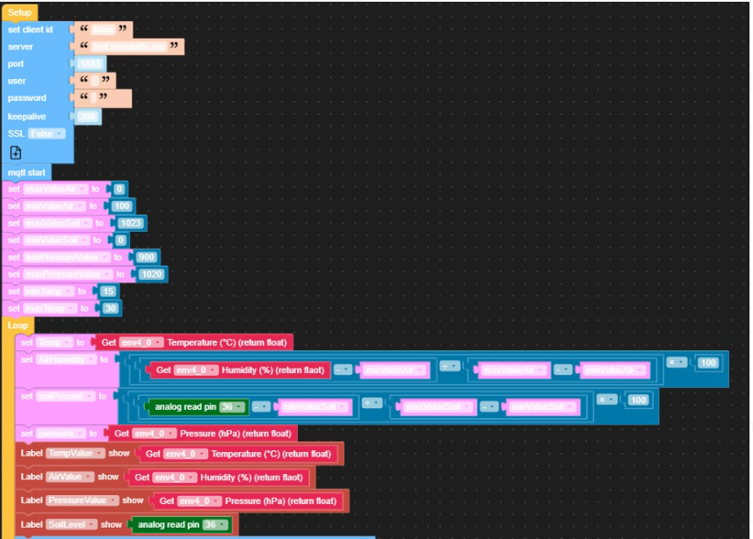**Software Design:**

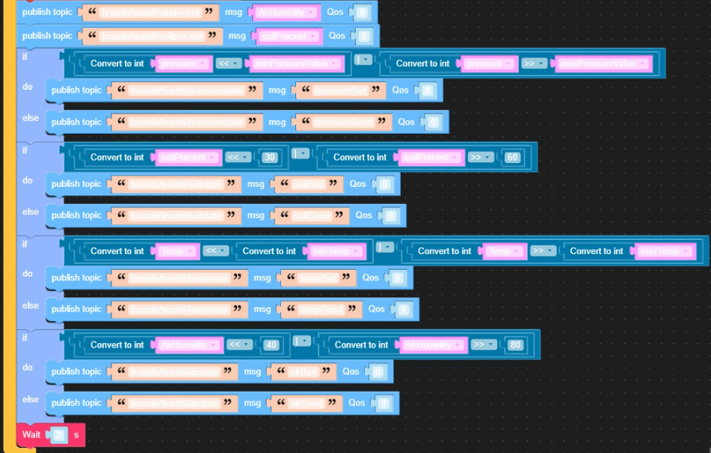

**Explanation of the code**

The system we developed utilizes M5Stack technology and the UiFlow environment. The code was written using the Blockly platform, which enables programming in Python through a visual interface that uses puzzle-like blocks to construct the code.

At the beginning of the development process, variables with numerical values were defined to reflect data from various sensors, including soil and air humidity, temperature, and atmospheric pressure. Each variable was assigned appropriate ranges based on data from different sources representing the environment of avocado trees. For continuous monitoring, a loop was implemented to collect real-time data from the sensors and update their values dynamically.

The data collected was displayed graphically on the controller's screen using labels, allowing users to track changes in real-time. To process the sensor data and provide meaningful insights, a computational system was formulated to convert the raw measurements into percentages, based on the observed ranges.

Additionally, the collected data was transmitted to the cloud for further analysis. Initially, an attempt was made to establish communication between two M5Stick Plus 2 controllers. This communication aimed to enable data transfer between systems and validate the integrity of the recorded values. The testing process involved evaluating the sensor value ranges, where any value meeting the predefined conditions was transmitted as valid data, while values outside the range were flagged as invalid.

The system, designed specifically for monitoring agricultural environments, provides essential tools for tracking the climatic and environmental conditions of avocado trees. It ensures continuous updates and supports informed, data-driven decision-making.

**Mechanical Design:**

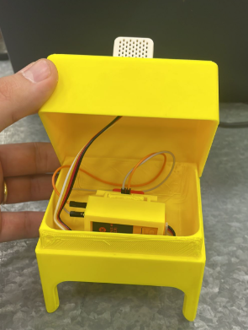We chose to 3D print the design we planned because manufacturing processes such as 3D printing enable the rapid and precise production of custom components. This technology allows for flexible design of complex structures, utilizing a variety of materials while reducing costs and production time compared to traditional methods

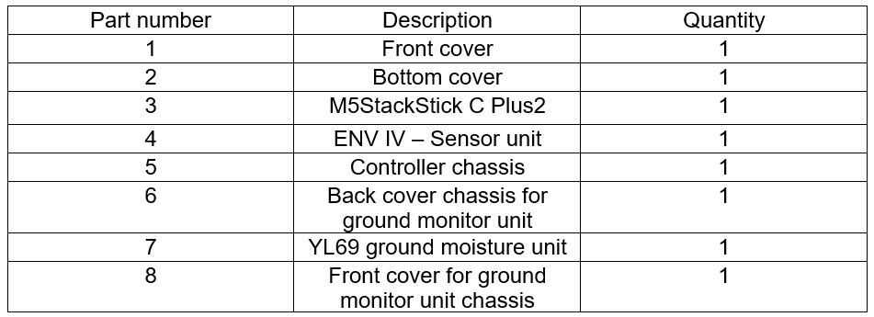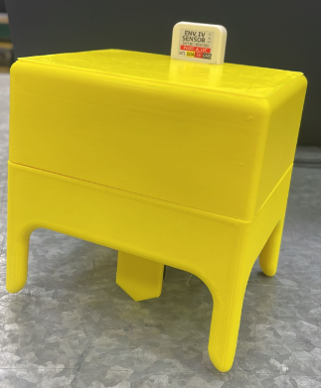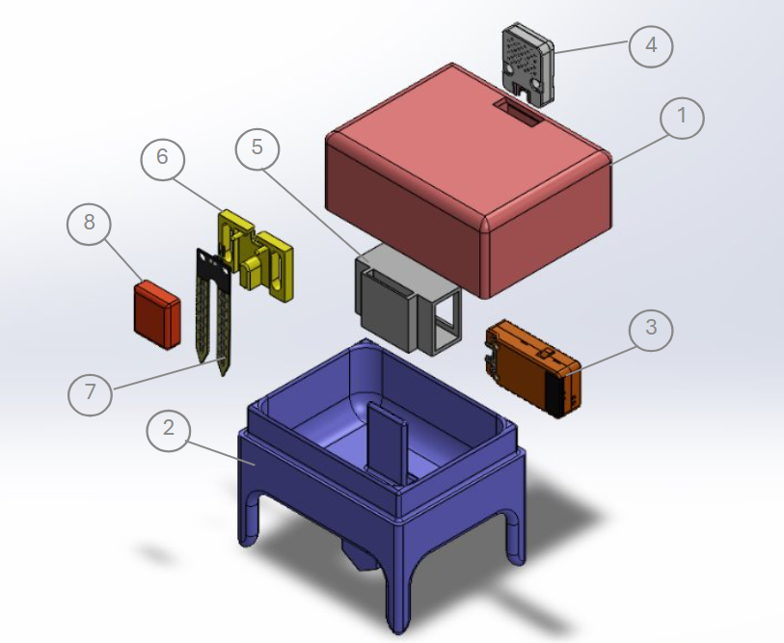

**Integration and testing**

### Integration Process

The integration process involved combining hardware, software, and mechanical components into a fully functional system.

* **Hardware:** Soil and air humidity sensors, the Unit V2 camera, and the M5Stick C Plus 2 controller were physically connected using a 3D-printed structure. Communication between components was ensured through precise wiring and Wi-Fi configuration.
* **Software:** The code was developed using the Blockly platform and integrated with the UiFlow environment. It enabled real-time data collection from sensors, image processing from the camera, and data transmission to the cloud for further analysis.
* **Mechanics:** The 3D-printed structure was designed to securely hold all components and position the camera at the optimal angle for leaf imaging. Mechanical adjustments were made to ensure suitability for agricultural environments.

### System Testing

**Testing Methodology:**

* **Functional Testing:**
  1. Verified sensor readings (humidity and temperature) under various environmental conditions.
  2. Tested the camera's ability to detect disease symptoms on leaves under different lighting angles.
* **Integration Testing:**
  1. Ensured seamless communication between hardware components via Wi-Fi, including data transmission from sensors and the camera to the controller and the cloud.
* **Real-Time Testing:**
  1. Evaluated the system's ability to provide continuous data updates and alert users about anomalies, such as out-of-range humidity levels.

**Test Results:**

* The sensors provided accurate data consistent with manual measurements for validation.
* The camera successfully detected changes in leaf color, though accuracy dropped under low lighting conditions.
* Communication between the controller and the cloud was stable, and data was displayed clearly in the graphical interface.

### System Performance Evaluation Against Original Requirements

The system meets part of the original requirements defined at the beginning of the project:

* **Detection of disease symptoms through leaf color:** The camera successfully identified changes in leaf color under specific lighting conditions, indicating symptoms of disease. However, improvements are needed in image processing for varied lighting and angles.
* **Monitoring soil and air humidity:** The sensors functioned correctly and provided accurate and timely humidity data, enabling monitoring of critical environmental conditions for tree health.
* **Real-time updates:** The system continuously transmits sensor and camera data, allowing for real-time tracking of tree conditions and alerts for values outside the predefined thresholds.

### Key Successes

* **Early disease detection:** The system was able to detect initial signs of disease on leaves, such as color changes or suspicious spots, supporting early identification of potential issues.
* **Environmental condition monitoring:** The soil and air humidity sensors provided accurate data, enabling an understanding of environmental factors affecting disease development.
* **Continuous monitoring:** The system updates data in real time, helping farmers identify immediate changes in environmental conditions or tree health.
* **Successful integration of components:** The camera, sensors, and controller worked together seamlessly, and the mechanical structure designed to hold all components proved efficient and durable.

### System Limitations and Areas for Improvement

* **Automation of actions:** The system currently provides alerts but does not perform automated actions, such as adjusting irrigation based on the measured humidity levels. Adding automation capabilities would enhance its functionality.
* **Weather resistance:** The current structure is suitable for basic conditions but needs reinforcement to withstand rain, high humidity, and strong winds.
* **Accuracy of alerts:** The computational system needs improvement to reduce false alarms and ensure more precise notifications for farmers.

### General Conclusions About the Project and Its Relevance to Smart Agriculture

The project demonstrates how advanced IoT technologies can be integrated with traditional agriculture to create innovative solutions tailored to the needs of modern farmers. The developed system provides effective tools for monitoring the environmental conditions and health of avocado trees, leveraging real-time data for early disease detection. The combination of sensors, a camera, and an advanced controller highlights the immense potential of IoT technologies to improve decision-making processes in agriculture.

The project’s relevance to smart agriculture lies in its ability to deliver accurate, data-driven solutions, enhance irrigation efficiency, reduce losses from diseases, and promote environmental sustainability by optimizing resource usage.

### Recommendations for Further Development, Scalability, or Alternative Applications

* **Enhancing Image Processing:**
  1. Integrate advanced artificial intelligence (AI) algorithms for higher accuracy in image analysis.
  2. Add machine learning capabilities to recognize disease patterns based on historical data.
* **Automation of Actions:**
  1. Connect the system to automated irrigation systems that adjust water levels based on humidity data.
  2. Incorporate smart climate control systems (e.g., fans or shading mechanisms) based on temperature and humidity readings.
* **Improving Durability:**
  1. Develop a more robust structure resistant to harsh field conditions, including waterproofing and UV-resistant materials.